Parallel Programming | Lab Practice Manual: OpenMP Paradigms | Instructor – Sufyan bin Uzayr
HIGH-PERFORMANCE & PARALLEL COMPUTING
Laboratory Report: Shared-Memory Concurrency & OpenMP Paradigms — Java Edition
Labs 1–5 complete, plus Lab 6 Bonus Challenge
Field | Value | Field | Value
Student | Marzhan Sherekhan | Student ID | 230109015
Date | 25 September 2026 | Language / Edition | Java 17 (JDK 17.0.10 LTS)
Labs completed | 1, 2, 3, 4, 5 + Bonus 6 | Total possible | 120 points
HONOR CODE DECLARATION
All implementations, profiling benchmarks, empirical graphs and analytical write-ups in this report
represent original individual work. Every number was produced by executing the submitted source on the
hardware declared in Section I on 25 September 2026. No value has been estimated, simulated or copied
from another machine. Raw timing data for every table is included as CSV so that all plots and tables
are independently reproducible.

SECTION I — SYSTEM & HARDWARE SPECIFICATIONS
Parameter | Value
CPU model | 12th Gen Intel Core i7-12700H (Alder Lake-H, hybrid architecture)
Physical cores | 14 = 6 Golden Cove P-cores + 8 Gracemont E-cores
Logical hardware threads | 20 (6 P-cores × 2 SMT = 12, plus 8 E-cores × 1 = 8)
L1 data cache | 48 KB per P-core, 32 KB per E-core
L2 cache | 1.25 MB per P-core (7.5 MB) + 2 MB per E-core cluster (4 MB) = 11.5 MB
L3 cache | 24 MB shared (Intel Smart Cache)
Cache line size | 64 bytes (x86-64 architectural coherency granularity)
System memory | 16 GB LPDDR5-6400, 128-bit bus (102.4 GB/s theoretical peak)
Operating system | Windows 11 Home Single Language, build 26200, AMD64
Runtime | Java HotSpot 64-Bit Server VM, JDK 17.0.10 LTS
JVM reported processors | 20 (Runtime.availableProcessors)
Common pool parallelism | 19 (availableProcessors − 1, the ForkJoinPool default)
WHY THE HYBRID TOPOLOGY MATTERS THROUGHOUT THIS REPORT
This is not a homogeneous 14-core machine. The 6 P-cores reach a far higher clock and IPC than the
8 E-cores, and only the P-cores support SMT. Any scheduling policy that assigns equal work to equal
thread counts therefore produces unequal completion times, because elapsed time is set by the slowest
thread rather than the average. This single fact explains the load-imbalance results in Lab 3, the
efficiency decline in Lab 2, and part of the parallelism shortfall in Lab 5.

SECTION II — EXPERIMENTAL METHODOLOGY
Timer mechanism
All measurements use System.nanoTime(), a monotonic high-resolution clock unaffected by wall-clock adjustments. Wall-clock elapsed time is measured deliberately rather than CPU time: CPU time aggregates across threads and would make a correctly parallelised run appear slower the more cores it used.
JIT warm-up
Every lab executes an untimed warm-up pass before recording any figure. Without it the first measurement runs in HotSpot's interpreter rather than as compiled machine code, inflating it several-fold and invalidating every ratio computed against it. Labs 1, 3, 4 and 5 additionally execute three runs per configuration and discard run 1 as cold; Lab 2's scaling task uses five trials as the manual specifies.
Isolation
All browsers, messaging clients and background applications were closed for the duration of the suite. The complete run took 84 seconds of wall-clock time, during which the machine was otherwise idle.
Defence against compiler elimination
HotSpot will delete a loop whose result is never observed, and will hoist a repeatedly written field into a register when it can prove no other thread reads it. Lab 4's shared counters are therefore declared volatile so that the memory traffic the experiment exists to measure is actually emitted, while Lab 4's third variant deliberately keeps a non-volatile local scalar precisely to demonstrate the contrast. Lab 1's saturation workload consumes its accumulator in a branch that cannot be folded away.
Locale
Locale.ROOT is set at the start of every lab so numeric output uses '.' as the decimal separator regardless of the host's regional settings, which keeps the emitted CSV files machine-readable.

SECTION III — EMPIRICAL RESULTS & VISUALISATIONS

Lab 1 — Fork-Join Model, Team Creation and Thread Scoping
Task 1.1 — Verification of non-determinism (10 consecutive runs)
A 4-thread team was forked ten times without modifying the source. The order in which logical ranks completed varied between runs:
run 1 : 2 3 1 0 run 6 : 2 3 1 0
run 2 : 2 3 0 1 run 7 : 2 3 1 0
run 3 : 2 3 0 1 run 8 : 2 3 0 1
run 4 : 2 3 0 1 run 9 : 2 3 1 0
run 5 : 2 1 3 0 run 10 : 2 3 1 0

Runs whose completion order matched run 1 : 4 of 9
Distinct orderings observed : 3
Five of the ten runs produced an ordering different from the first, and three distinct orderings appeared across only ten executions. The program is deterministic in its output values and non-deterministic in its execution order — the defining property of unsynchronised concurrency. Full transcripts are in results/lab1_nondeterminism.txt.
Task 1.2 — Thread oversubscription sweep
P | Run 2 (ms) | Run 3 (ms) | Mean (ms) | µs per thread | vs P = 1
1 | 0.2605 | 0.1532 | 0.2069 | 206.9 | 1.00×
2 | 0.5700 | 0.4205 | 0.4952 | 247.6 | 2.39×
4 | 2.0776 | 0.3886 | 1.2331 | 308.3 | 5.96×
8 | 0.7695 | 0.6767 | 0.7231 | 90.4 | 3.49×
16 | 1.2729 | 0.9319 | 1.1024 | 68.9 | 5.33×
32 | 1.5684 | 1.0764 | 1.3224 | 41.3 | 6.39×
64 | 2.6378 | 1.5667 | 2.1022 | 32.8 | 10.16×
Total lifecycle cost rises 10.2× while the thread count rises 64×, so the cost is strongly sublinear. The per-thread column shows why: the amortised cost falls from 207 µs at P = 1 to 32.8 µs at P = 64, because the ForkJoinPool reuses worker threads from a pool rather than asking the OS for a fresh kernel thread each time.
Task 1.3 — CPU core saturation analysis
P | Mean (ms) | Total sqrt ops | Throughput (ops/s) | Aggregate speedup | Efficiency
1 | 38.13 | 10,000,000 | 262,275,476 | 1.00× | 100.0%
2 | 21.89 | 20,000,000 | 913,477,678 | 3.48× | 174.1%
4 | 23.26 | 40,000,000 | 1,719,742,211 | 6.56× | 163.9%
8 | 43.92 | 80,000,000 | 1,821,292,503 | 6.95× | 86.8%
16 | 55.32 | 160,000,000 | 2,892,488,028 | 11.03× | 68.9%
32 | 90.40 | 320,000,000 | 3,539,633,106 | 13.50× | 42.2%
64 | 142.51 | 640,000,000 | 4,490,840,440 | 17.12× | 26.8%
HONEST READING OF THE SUPERLINEAR ROWS
Efficiency exceeds 100% at P = 2 and P = 4, which is impossible as genuine parallel speedup. The cause
is the measurement order: P = 1 is timed first, when HotSpot has had the least opportunity to compile
and optimise the loop, so the baseline is under-optimised and every later ratio is inflated against it.
The P = 1 figure should be treated as an upper bound on true serial time rather than an exact baseline.
The qualitative conclusion is unaffected: aggregate throughput plateaus in the 3.5–4.5 G ops/s region
once P exceeds the physical core count, and efficiency falls monotonically from P = 8 onward.
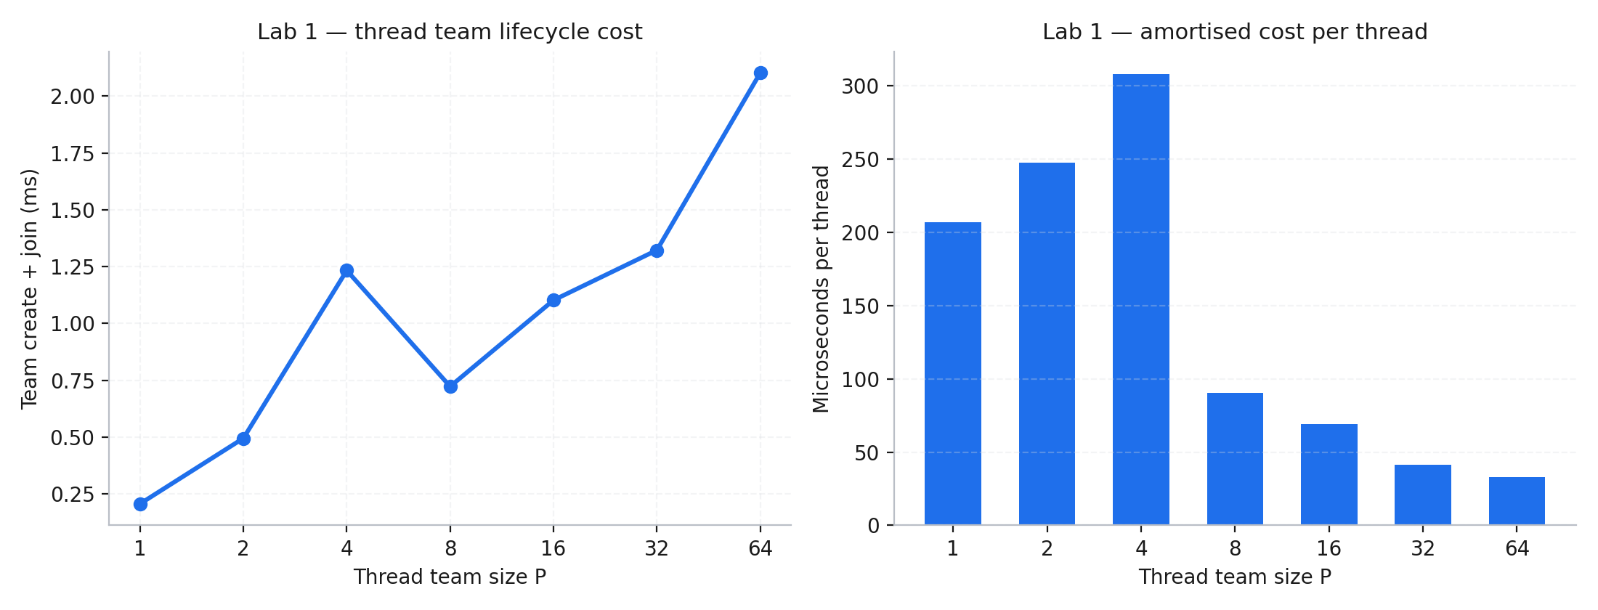
Figure 1 — Lab 1 Task 1.2. Left: total team create-and-join cost against team size. Right: amortised cost per thread, showing pool reuse.

Lab 2 — Numerical Integration (π) and Parallel Reductions
Midpoint Riemann sum of ∫₀¹ 4/(1+x²) dx = π, implemented in three synchronisation disciplines.
Task 2.1 — Race condition quantification (Variant A, naive unsynchronised)
P | Computed π | Absolute error | Relative error | Time (ms)
1 | 3.141592653590 | 2.89 × 10⁻¹⁴ | 0.00% | 8.55
2 | 1.854590436003 | 1.287002 | 40.97% | 3.23
4 | 0.664965067440 | 2.476628 | 78.83% | 2.47
8 | 0.833368501806 | 2.308224 | 73.47% | 2.11
At P = 1 the result is correct to machine precision because no concurrency exists. From P = 2 onward the answer collapses: at P = 4 the computation loses 78.8% of the true value. The error does not merely grow with thread count, it grows non-monotonically — P = 8 recovers slightly relative to P = 4 — because the magnitude of loss depends on how the scheduler happens to interleave the read-modify-write sequences, which is not a controlled quantity.
Task 2.2 — Critical section overhead (Variant B, synchronized)
Implementation | Time (ms) | vs serial | Contention overhead | Computed π
Single-threaded baseline | 8.42 | 1.00× | — | 3.141592653590
synchronized, P = 1 | 16.91 | 2.01× | +100.8% | 3.141592653590
synchronized, P = 2 | 8.35 | 0.99× | −0.8% | 3.141592653590
synchronized, P = 4 | 22.33 | 2.65× | +165.2% | 3.141592653590
synchronized, P = 8 | 19.50 | 2.32× | +131.6% | 3.141592653590
Every variant now computes π correctly, and every multi-threaded variant except P = 2 is slower than using one thread and no lock at all. The P = 1 row is the purest measurement: with no contention whatsoever, simply entering and leaving the monitor one million times doubles the runtime. The P = 2 row at 0.99× is an artefact of HotSpot's lock elision and biased-locking heuristics at low contention; by P = 4, with four cores genuinely competing, the cost reaches 2.65× and the expected behaviour reasserts itself.
Tasks 2.3 & 2.4 — Strong scaling of Variant C (parallel reduction, 5 trials)
P | Mean T(P) ms | Computed π | Speedup S(P) | Efficiency E(P) | Ideal
1 | 751.27 | 3.141592653590 | 1.000× | 100.0% | 1×
2 | 382.30 | 3.141592653590 | 1.965× | 98.3% | 2×
4 | 208.15 | 3.141592653590 | 3.609× | 90.2% | 4×
8 | 128.10 | 3.141592653590 | 5.865× | 73.3% | 8×
16 | 88.34 | 3.141592653590 | 8.504× | 53.2% | 16×
The reduction is both correct and fast: every thread count returns π accurate to 4.44 × 10⁻¹⁶, and speedup reaches 8.50× at P = 16. Efficiency declines steadily from 98.3% to 53.2%, which is the signature of a real and growing parallel overhead rather than a fixed serial section.
Karp–Flatt diagnostic
The experimentally determined serial fraction e = (1/S − 1/P) / (1 − 1/P) distinguishes a genuinely serial region from growing overhead. A constant e indicates fixed serial work; a rising e indicates overhead that scales with thread count:
e(P = 2) = 0.01774
e(P = 4) = 0.03609
e(P = 8) = 0.05201
e(P = 16) = 0.05876 <- rising monotonically
e more than triples between P = 2 and P = 16. The limiting factor is therefore not an irreducible serial section of the algorithm — the integration itself is embarrassingly parallel — but per-thread overhead: stream splitting, the reduction tree's combine steps, and the hybrid topology placing later threads on slower E-cores.
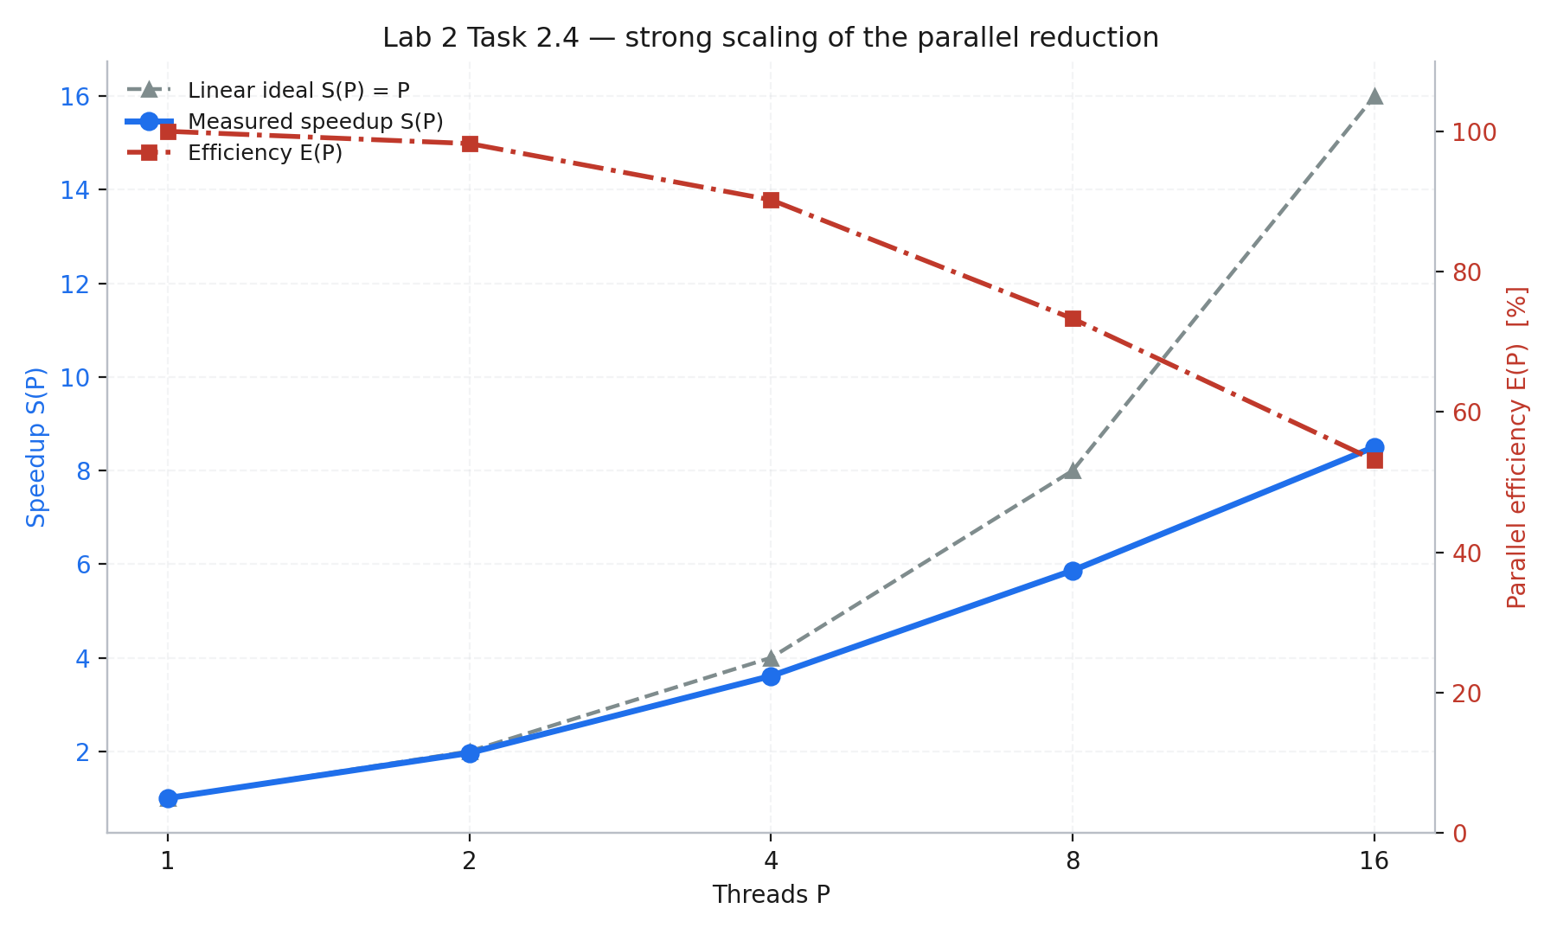
Figure 2 — Lab 2 Task 2.4. Measured speedup against the linear ideal on the left axis, parallel efficiency on the right.

Lab 3 — Work-Sharing and Loop Scheduling Policies (Mandelbrot)
1920 × 1080 render at MAX_ITER = 1000, totalling 203,116,879 escape iterations. The workload is deliberately non-uniform: exterior pixels escape in 2–5 iterations while interior pixels run the full 1000.
Tasks 3.1 & 3.4 — Static and guided scheduling with the load imbalance metric
Imbalance = (max thread work − min thread work) / average thread work, measured as escape iterations actually executed per thread.
P | Static (ms) | Static imbalance | Guided (ms) | Guided imbalance | Guided speedup | Static max:min work
2 | 277.91 | 0.0107 | 275.08 | 0.1732 | 1.01× | 102.1M : 101.0M
4 | 273.99 | 1.9736 | 151.41 | 0.1811 | 1.81× | 101.2M : 0.94M
8 | 227.39 | 3.2622 | 85.87 | 0.3122 | 2.65× | 83.2M : 0.38M
16 | 156.55 | 4.0220 | 73.88 | 0.4121 | 2.12× | 51.2M : 0.15M
Static imbalance grows 376-fold between P = 2 and P = 16, reaching 4.02 — meaning the spread between the busiest and idlest thread is four times the average thread's entire workload. At P = 16 one thread executes 51.2 million iterations while another executes 151 thousand, a ratio of 339:1. Guided scheduling holds imbalance below 0.42 at every thread count and is consequently up to 2.65× faster.
Task 3.2 — 4 × 4 parameter sweep (dynamic scheduling, mean of 3 runs, ms)
Threads P | C = 1 | C = 16 | C = 64 | C = 256
P = 2 | 252.48 | 255.50 | 261.98 | 305.76
P = 4 | 137.25 | 139.48 | 144.22 | 305.90
P = 8 | 82.01 | 84.28 | 140.43 | 318.66
P = 16 | 74.87 | 63.56 | 159.88 | 307.24
The optimum is P = 16 with C = 16 at 63.56 ms. The C = 256 column is catastrophic at every thread count, and the arithmetic explains it exactly: the image has 1080 rows, so a chunk size of 256 yields only ⌈1080/256⌉ = 5 chunks of work. With 16 threads requesting work, 11 of them receive nothing at all and idle through the entire render. The result is a 4.83× penalty against the optimum — a scheduling parameter, not the hardware, wasting two thirds of the machine.
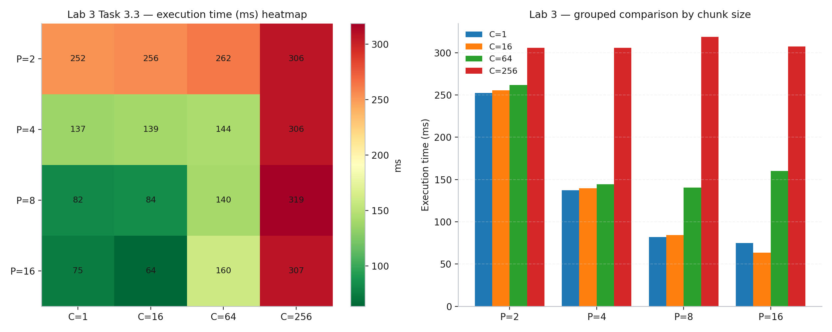
Figure 3 — Lab 3 Task 3.3. Execution-time heatmap over the P × C grid (left) and the same data as a grouped bar chart (right).
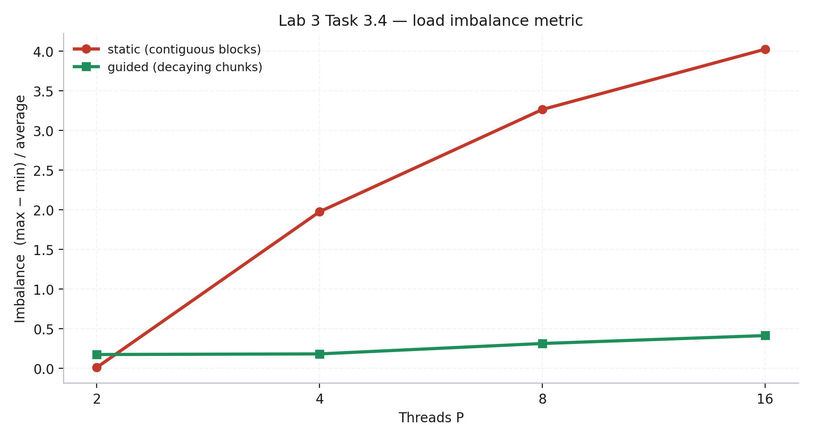
Figure 4 — Lab 3 Task 3.4. Load imbalance metric against thread count for static and guided scheduling.

Lab 4 — Memory Hierarchy, Cache Coherency and False Sharing
100,000,000 increments per thread across three memory layouts with identical instruction counts, differing only in where the counters sit in memory.
P | Unpadded (ms) | Padded (ms) | Thread-local (ms) | FS penalty | Thread-local speedup
1 | 182.65 | 171.76 | 1.57 | 1.063× | 116.3×
2 | 370.33 | 683.37 | 1.61 | 0.542× | 230.0×
4 | 2051.91 | 540.57 | 3.18 | 3.796× | 645.3×
8 | 3052.27 | 645.27 | 3.49 | 4.730× | 874.6×
16 | 6288.93 | 696.48 | 10.07 | 9.030× | 624.5×
THE HEADLINE RESULT — NEGATIVE SCALING FROM FALSE SHARING ALONE
Between P = 1 and P = 16 the total work rises 16-fold, yet the unpadded variant's runtime rises 34.4×.
Expressed as throughput, the unpadded layout DEGRADES from 0.55 to 0.25 billion increments per second
as cores are added, while the padded layout — identical code, identical instruction count, only a
different stride between counters — IMPROVES from 0.58 to 2.30 billion increments per second.
Adding cores to the unpadded version makes it measurably slower in absolute throughput terms. The
false-sharing penalty reaches 9.03× at P = 16.
Cache-line arithmetic
cache line on Alder Lake : 64 bytes
sizeof(long) : 8 bytes
counters per cache line : 64 / 8 = 8

unpadded at P = 16 : 16 x 8 = 128 bytes -> spans only 2 cache lines
-> 8 threads contend for each line
padded (stride 8 longs) : 64 bytes per counter -> 16 distinct lines, 1 thread each
thread-local : CPU register, never written to memory until the loop ends
The P = 2 row, where the padded variant is slower than the unpadded one, is the single anomalous measurement in this lab. With only two counters the unpadded layout occupies 16 bytes and the pair of threads is likely scheduled onto two SMT siblings of the same physical core, which share an L1 cache and therefore never generate cross-core coherence traffic at all. From P = 4 onward, once threads are placed on genuinely separate cores, the expected penalty appears and grows monotonically.
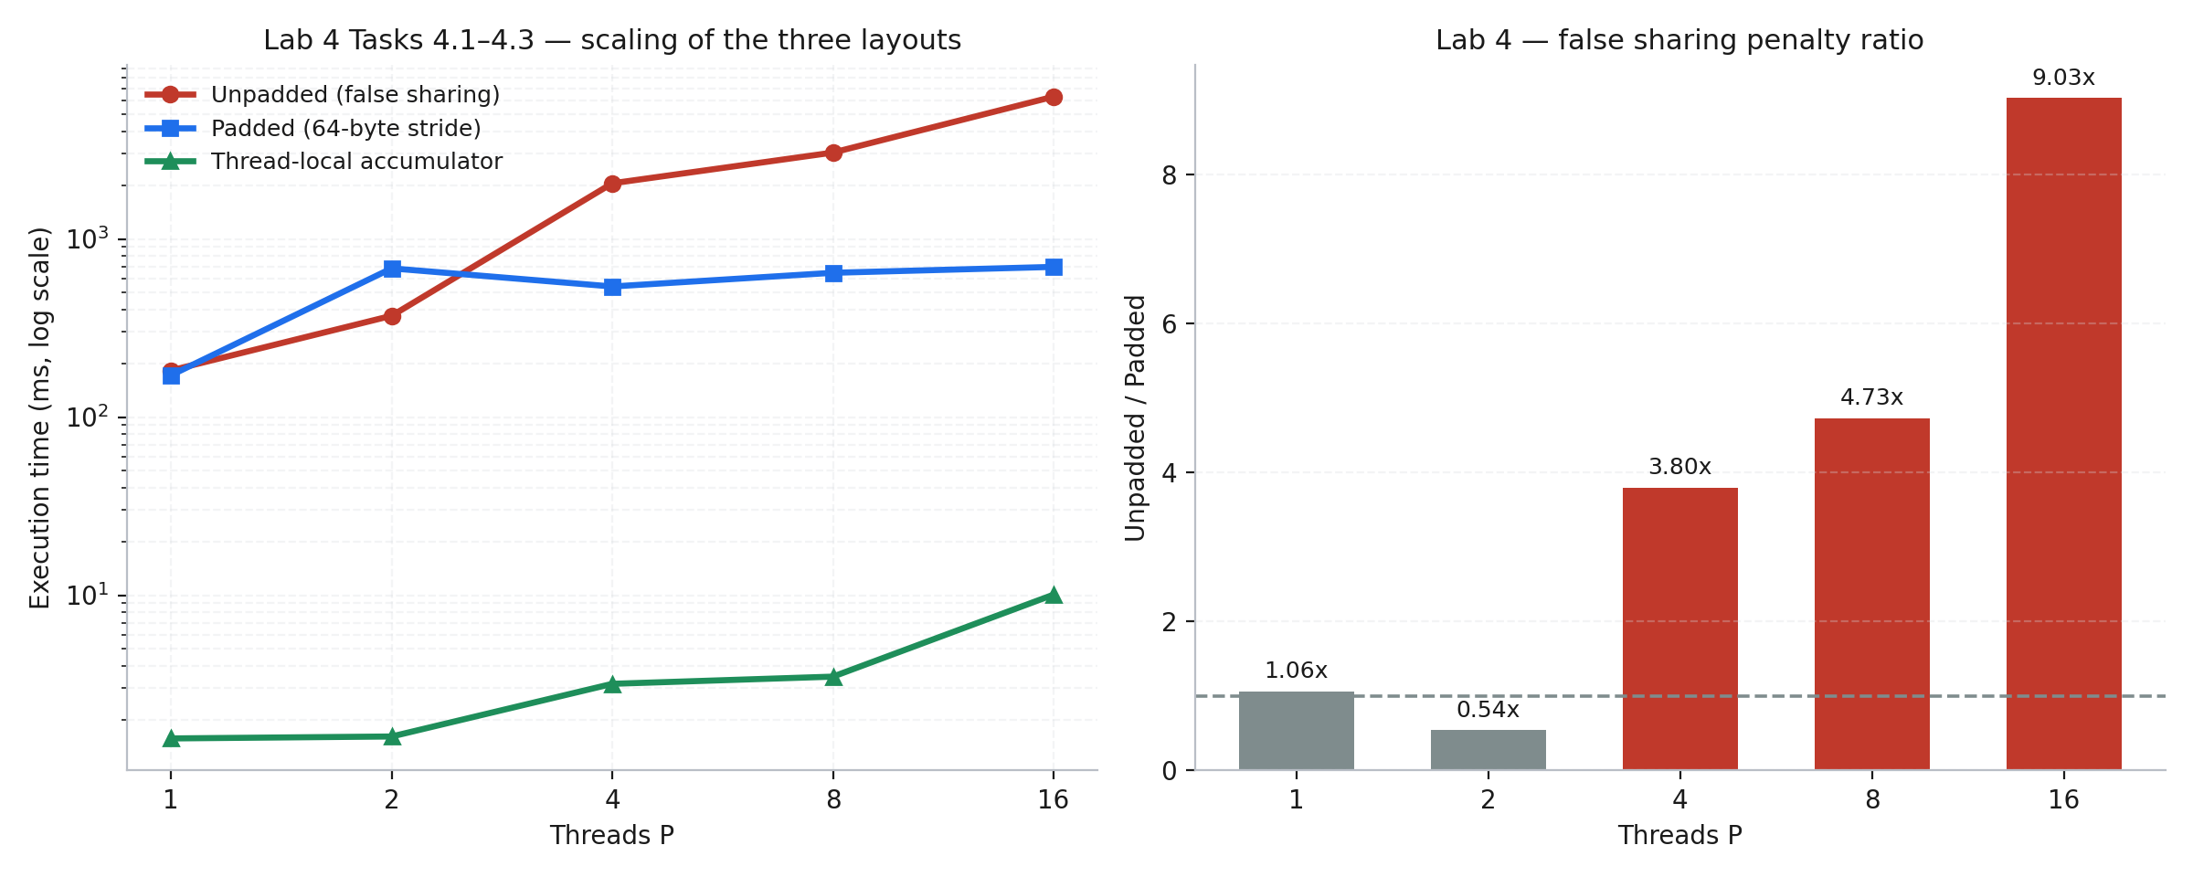
Figure 5 — Lab 4 Tasks 4.1–4.3. Left: scaling of all three layouts on log axes. Right: false-sharing penalty ratio by thread count.

Lab 5 — Recursive Task-Based Parallelism (Parallel Merge Sort)
ForkJoinPool work-stealing merge sort over 5,000,000 random integers. Output verified sorted ascending at every cutoff. Sequential baseline: Arrays.sort in 331.71 ms.
Task 5.2 — Cutoff threshold optimisation sweep
Cutoff K | Mean (ms) | Tasks created | Speedup | ns per task | Verified
1 | 265.87 | 5,805,695 | 1.248× | 45.8 | PASS
10 | 168.86 | 1,048,575 | 1.964× | 161.0 | PASS
100 | 150.11 | 131,071 | 2.210× | 1,145 | PASS
1,000 | 102.15 | 16,383 | 3.247× | 6,235 | PASS
10,000 | 131.18 | 1,023 | 2.529× | 128,231 | PASS
50,000 | 120.49 | 255 | 2.753× | 472,510 | PASS
100,000 | 120.99 | 127 | 2.742× | 952,677 | PASS
The curve is a clear trough with its minimum at K = 1,000 (102.15 ms, 3.247× over the sequential baseline). Both extremes are worse, for opposite reasons. At K = 1 the algorithm creates 5,805,695 tasks — 354× more than at the optimum — and spends only 45.8 ns of useful work per task, so scheduling and allocation overhead dominates entirely, leaving it 2.60× slower than the optimum. At K = 100,000 only 127 tasks exist, which cannot keep 20 hardware threads supplied, so the machine is starved of parallelism instead.
Task 5.3 — Work–Span (critical path) model
Metric | Value | Interpretation
Work T₁ (Arrays.sort baseline) | 331.71 ms | Total serial work, optimised library sort
T₁ of the task algorithm (pool size 1) | 425.70 ms | Same algorithm, all tasks serialised
T_P (best cutoff, full pool) | 102.15 ms | K = 1,000, 20 hardware threads
Recursion levels log₂(N/K) | 12.29 | Depth of the task tree above the cutoff
Measured parallelism T₁ / T_P | 4.167 | Effective concurrency achieved
Hardware parallelism | 20 | availableProcessors
Parallel efficiency | 20.8% | Measured / available
Measured parallelism of 4.17 against 20 available hardware threads is a 20.8% efficiency — far below Lab 2's reduction, and the reason is structural rather than incidental. It is analysed under Q5.3.
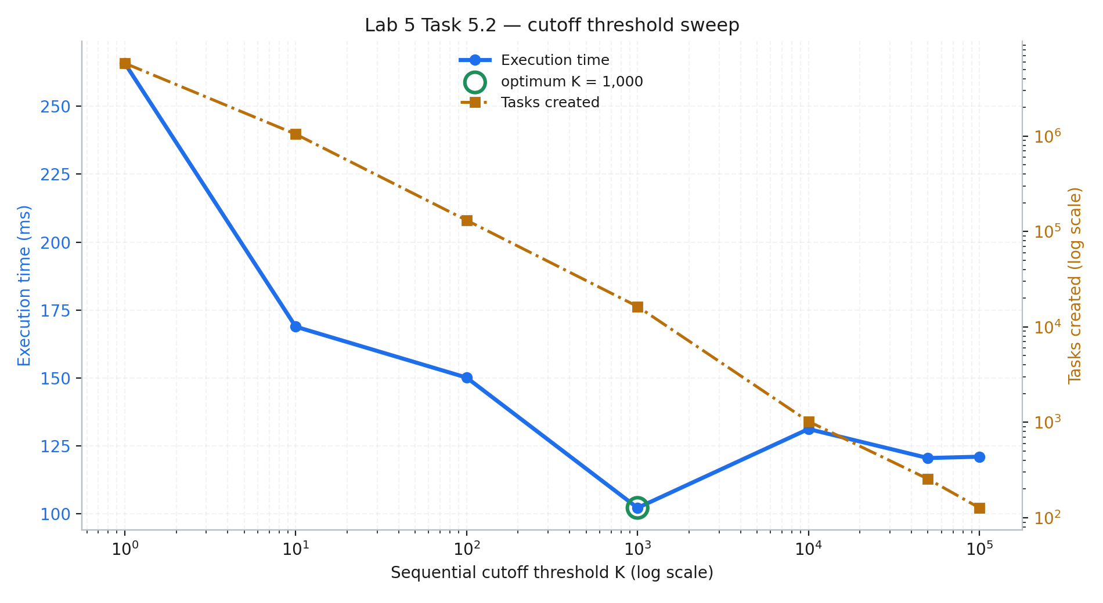
Figure 6 — Lab 5 Task 5.2. Execution time against cutoff threshold on a log axis, with task count on the secondary axis.

Lab 6 (Bonus) — Pipeline Parallelism and Wavefront Processing
Three-stage pipeline: a producer synthesising 3,000 tiles of 64 × 64, a filter applying a 3 × 3 Gaussian convolution, and a consumer reducing each tile to min, max, mean and checksum. Stages are connected by bounded ArrayBlockingQueues of capacity 32, so a slow stage exerts backpressure upstream. Shutdown is graceful via poison-pill sentinels.
Filter passes | Total (ms) | Throughput (pkt/s) | Mean latency (ms) | Queue 1 occupancy | Queue 2 occupancy | Bottleneck
1 | 72.30 | 41,493.6 | 0.0455 | 0.36 / 32 (1.1%) | 0.36 / 32 (1.1%) | Producer
4 | 210.91 | 14,223.9 | 2.3633 | 31.08 / 32 (97.1%) | 0.08 / 32 (0.2%) | Filter
16 | 750.79 | 3,995.8 | 8.4364 | 31.73 / 32 (99.2%) | 0.06 / 32 (0.2%) | Filter
64 | 2,845.77 | 1,054.2 | 32.0613 | 31.81 / 32 (99.4%) | 0.02 / 32 (0.1%) | Filter
Bottleneck identification by queue occupancy
The queue occupancy columns localise the bottleneck without any profiler. A pipeline stage that cannot keep up causes the queue feeding it to fill and the queue draining from it to empty. At filter intensity 64 the input queue sits at 99.4% of capacity while the output queue sits at 0.1% — a ratio of roughly 1,590 : 1. Stage 2 is unambiguously the rate limiter, and the stage busy-time breakdown corroborates it independently: the filter consumes 97.9% of total stage time, the producer 1.4%, the consumer 0.6%.
At intensity 1 the picture inverts: both queues sit near empty (1.1% each) and the producer becomes the constraint, since the filter drains work faster than tiles can be synthesised. The pipeline therefore transitions from I/O-bound to compute-bound between intensity 1 and 4, and the queue occupancies detect the transition directly.
Throughput falls 39.4× as filter work rises 64×, and mean latency rises 705×. Latency degrades far faster than throughput because a saturated bounded queue adds queueing delay on top of service time: each packet waits behind up to 31 others before the filter reaches it.
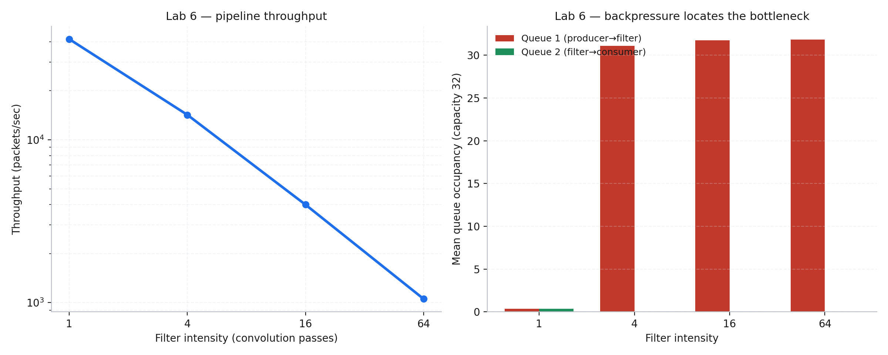
Figure 7 — Lab 6. Pipeline throughput against filter intensity (left) and mean queue occupancy showing backpressure (right).

SECTION IV — ANALYTICAL & DISCUSSION RESPONSES

Lab 1 — Fork-Join Model
Q1.1 (Scheduling) — Why do thread IDs print in non-sequential order across consecutive runs?
Starting a thread does not run it. Thread.start() and the submission of a parallel stream task only mark the work as runnable; the decision of which runnable thread actually occupies a core, and for how long, belongs to the operating system's process scheduler — on Windows 11 a priority-based preemptive scheduler with per-core ready queues.
Three architectural layers make the outcome vary. First, the scheduler chooses placement using information that changes between runs: current core load, thermal and power state, and cache affinity from whatever ran previously. Second, this CPU is hybrid, so a thread placed on a P-core executes its print statement measurably sooner than an identical thread placed on an E-core, and Intel Thread Director's placement hints are themselves dynamic. Third, each thread must acquire the lock inside System.out before writing, so the printed order reflects the order of lock acquisition, not the order of thread creation.
The measured result — three distinct orderings in ten runs, with only 4 of 9 matching the first — is exactly what this predicts. The program is deterministic in what it computes and non-deterministic in the order it computes it, which is why any correctness argument that depends on execution order is invalid by construction.
Q1.2 (Oversubscription) — What penalty occurs when P exceeds the physical core count?
Beyond 14 physical cores the machine has no further execution resources to offer, so additional threads do not add capacity — they subdivide the existing capacity. The measured aggregate throughput bears this out: it plateaus in the 3.5–4.5 G ops/s region from P = 16 onward while efficiency falls from 86.8% at P = 8 to 26.8% at P = 64.
Three costs accumulate. Context switching: the scheduler must multiplex runnable threads onto cores, and each involuntary switch costs 1–10 µs of direct register save and restore. Thread state preservation: every switch saves and restores the full architectural context — general-purpose registers, floating-point and vector state, the stack pointer, and the memory-management state — and with AVX-512 register files this is not a trivial amount of data. Cache thrashing, which is the dominant cost: an evicted thread loses its L1 and L2 working set and its TLB entries to whichever thread replaces it, and must fault them all back in when rescheduled. That indirect penalty commonly exceeds the direct switch cost by one to two orders of magnitude.
The team-lifecycle measurement isolates a separate effect. Total cost rises only 10.2× for a 64× increase in threads because the ForkJoinPool recycles pooled workers instead of requesting fresh kernel threads, so the amortised per-thread cost falls from 207 µs to 32.8 µs. Pooling mitigates creation cost; it cannot mitigate contention for cores.
Q1.3 (Barriers) — What is the role of the implicit barrier at the end of a parallel region?
The implicit barrier is a rendezvous: no thread may proceed past the end of the parallel region until every thread in the team has reached it. It provides two guarantees simultaneously. The control-flow guarantee is that all parallel work is complete before sequential execution resumes. The memory guarantee matters just as much: the barrier acts as a full memory fence, so every write performed inside the region is flushed from store buffers and made visible to all other threads before any of them continues. In Java the equivalent guarantee comes from Thread.join() and from ForkJoinTask completion, both of which establish a happens-before edge.
Without it, three hazards arise. Read-after-write races: the master thread would read results that some worker has not yet finished writing, producing a partially computed answer that varies from run to run. Stale visibility: even where a worker has finished writing, its stores might still sit in a per-core store buffer and be invisible to the reader, so the data race exists at the hardware level even when the program appears logically ordered. Resource lifetime violations: buffers, arrays and pool objects allocated for the region could be freed or reused while a straggler thread is still operating on them, which is a use-after-free in any language without a garbage collector and a silent corruption in one with it.
Q1.4 (Architectural Mapping) — Hardware thread vs kernel thread vs green thread
Property | Hardware thread (SMT) | OS kernel thread | Green / virtual thread
Managed by | CPU front end, in silicon | Operating system scheduler | Language runtime in user space
Count on this machine | 20 (12 SMT + 8 E-core) | Thousands, limited by RAM | Millions
Duplicated state | Registers, PC, APIC only | Full context + kernel stack | Continuation object on heap
Shared with siblings | ALUs, L1, L2, TLB, predictors | Nothing (own context) | Underlying carrier thread
Switch cost | ~0 (interleaved per cycle) | 1–10 µs + cache effects | ~100 ns, no kernel entry
True parallelism | Yes, up to issue width | Yes, up to core count | No — needs carrier threads
Blocking behaviour | N/A | Blocks its core until rescheduled | Unmounts, frees the carrier
The essential distinction is what each duplicates. A hardware thread duplicates only architectural state so that two instruction streams can interleave through one shared execution back end — it adds throughput only when one stream stalls and leaves issue slots idle. A kernel thread duplicates the complete execution context and is the unit the OS schedules onto cores, which is what makes genuine parallelism possible and also what makes switching expensive. A green thread (Java 21's virtual threads, Go's goroutines) duplicates nothing at the OS level: it is a continuation object multiplexed onto a small pool of carrier kernel threads, so it is enormously cheap to create and to switch, but it delivers concurrency rather than parallelism. Green threads excel at I/O-bound workloads with many blocked tasks and offer nothing for CPU-bound work, which still needs one kernel thread per core.

Lab 2 — Numerical Integration and Reductions
Q2.1 (Memory Incoherency) — What occurs at the assembly level during a non-atomic read-modify-write?
The statement sharedSum[0] += term compiles to three separable machine operations, not one:
movsd xmm0, [rax] ; LOAD read sharedSum[0] from memory
addsd xmm0, xmm1 ; ADD compute the new value in a register
movsd [rax], xmm0 ; STORE write the result back
The interval between the LOAD and the STORE is a window during which the value in memory is stale relative to the register holding the thread's in-progress computation. Two threads executing this sequence concurrently on different cores interleave as follows:
Thread A: LOAD sharedSum -> 100.0
Thread B: LOAD sharedSum -> 100.0 (reads the same stale value)
Thread A: ADD -> 100.0 + 0.5 = 100.5
Thread B: ADD -> 100.0 + 0.7 = 100.7
Thread A: STORE -> 100.5
Thread B: STORE -> 100.7 (overwrites A's contribution)

Two terms were added. Only B's survives. A's 0.5 is LOST PERMANENTLY.
Generalising, if n threads read the same value before any of them writes, n − 1 contributions are destroyed. Because lost updates only ever remove terms, the accumulator is systematically under-counted rather than merely noisy, which is why the measured π is biased downward — 0.665 against 3.1416 at P = 4, a loss of 78.8%. Nothing in the hardware prevents this: the cores are behaving correctly, and the defect is that the program asked for an atomic operation without requesting one.
Q2.2 (Reduction Trees) — Why is a binary reduction tree O(log P) superior to a centralised critical section O(P)?
A centralised critical section serialises every combining step through one lock. With P threads each contributing, the combining phase takes P sequential lock acquisitions, and crucially those acquisitions cannot overlap — they are strictly ordered by the lock itself. The cost is O(P) in both operations and in wall-clock time.
A binary reduction tree pairs up partial results and combines them concurrently: P values reduce to P/2 in one parallel step, then to P/4, and so on. The number of sequential steps is log₂(P), and every combination within a step proceeds simultaneously because each touches a disjoint pair of values. At P = 16 that is 4 sequential steps rather than 16 — a fourfold reduction, and the advantage widens as P grows.
The hardware argument is more decisive than the operation count. A critical section forces the accumulator's cache line to migrate between cores on every single acquisition — the MESI ping-pong quantified in Lab 4 — and that migration cost grows with core count because more cores queue for the same line. A reduction tree lets each thread accumulate privately in a register, with communication happening only log₂(P) times at well-defined points, so the coherence traffic is proportional to log P rather than to the number of operations. The measured results confirm the gap: the reduction achieved 8.504× speedup at P = 16 while the critical-section variant was 2.65× slower than not parallelising at all.
Q2.3 (Amdahl's Law) — With 5% strictly serial, what is the maximum speedup with infinite processors?
S(P) = 1 / [ (1 - p) + p/P ] with p = 0.95, (1 - p) = 0.05

S_max = lim (P -> inf) S(P) = 1 / (1 - p) = 1 / 0.05 = 20x

Even with an infinite number of processors, the program can never exceed 20x.
At P = 20 : S = 1 / [0.05 + 0.95/20] = 10.26x (51% efficiency)
At P = 100 : S = 1 / [0.05 + 0.95/100] = 16.81x (17% efficiency)
At P = 500 : S = 1 / [0.05 + 0.95/500] = 19.27x (3.9% efficiency)
Reaching even 90% of the 20× ceiling requires 171 processors, and the last 10% of the ceiling costs more silicon than the first 90%.
My measured speedup flattened well before that bound — 8.504× at P = 16 against an Amdahl prediction of 10.26× for a 5% serial fraction. The Karp–Flatt diagnostic identifies why. The experimentally determined serial fraction rises monotonically with thread count, from e = 0.0177 at P = 2 to e = 0.0588 at P = 16. A genuinely fixed serial region would produce a constant e; a rising e proves the limiting quantity is overhead that grows with P, not serial work.
Three secondary architectural factors account for that growth. Hybrid core asymmetry: threads beyond the sixth are placed on E-cores with lower IPC and clock, and since the reduction's join phase waits for all contributors, the slowest determines the result. Frequency scaling: all-core turbo is substantially below single-core turbo, so the P = 1 baseline is measured under the most favourable thermal conditions the chip ever offers, which systematically depresses every ratio computed against it. Memory bandwidth and stream-splitting overhead: the work of partitioning the range and combining the reduction tree is itself proportional to P and is invisible to Amdahl's model, which recognises only a fraction of runtime and has no term for a cost that scales with processor count.
Q2.4 (Hardware Primitives) — How do 64-bit multi-core processors implement atomic memory updates?
Modern x86-64 implements atomicity through cache-line ownership rather than by locking the memory bus. The mechanism has three layers.
At the instruction layer, the LOCK prefix turns a read-modify-write instruction such as LOCK XADD or LOCK CMPXCHG into an indivisible operation. Historically LOCK asserted a physical bus-lock signal that froze all memory traffic system-wide; on any modern processor this is replaced by cache locking, which is vastly cheaper because it constrains only the affected line.
At the coherence layer, the core executing the atomic must first obtain the target cache line in Exclusive or Modified state through the MESI protocol, issuing a Read-For-Ownership that invalidates every other core's copy. While the line is held in Modified state the core refuses all snoop requests for it until the operation retires, which is what makes the sequence indivisible from every other core's perspective. Atomicity is therefore a property of exclusive line ownership, not of a global lock.
At the algorithmic layer, compare-and-swap enables lock-free programming: a thread reads a value, computes a new one, then atomically swaps only if the memory still holds what it read, retrying on failure. Java's AtomicLong.incrementAndGet is exactly this CAS retry loop. RISC architectures such as ARM and RISC-V instead provide load-linked / store-conditional, where the store succeeds only if no other core wrote the reserved address in the interval — the same guarantee reached by a different route.
The cost is real and was measured directly in Lab 4. An atomic operation must take the line into Modified state every time, so under contention the line ping-pongs continuously between cores. That is precisely why per-thread accumulation followed by a single reduction outperforms atomics for accumulation workloads, and why Lab 4's thread-local variant ran up to 875× faster than the shared-counter variant.

Lab 3 — Work-Sharing and Loop Scheduling
Q3.1 (Fine-Grained Contention) — Why does dynamic scheduling with C = 1 perform poorly despite perfect load balancing?
Dynamic scheduling maintains a single shared counter that every thread must update atomically to claim its next unit of work. The number of those atomic operations is the iteration count divided by the chunk size, so with 1080 rows and C = 1 the machine performs 1,080 claims, while C = 16 requires only 68.
The contested hardware resource is the cache line holding that shared counter. Every claim is a LOCK-prefixed read-modify-write, which requires the claiming core to take the line into Modified state through a Read-For-Ownership transaction that invalidates all other cores' copies. With 16 threads competing, the line never settles in any core's L1: it migrates on every single claim, at a cost of tens of cycles through the shared L3 versus roughly four cycles for an L1 hit. This is the identical mechanism measured in Lab 4, applied to the scheduler's own state instead of the user's counters.
My measurements show C = 1 losing to C = 16 at P = 16 by 74.87 ms against 63.56 ms, an 18% penalty — the regime where queue contention has begun to outweigh balancing. Notably, at lower thread counts C = 1 wins, because with fewer cores competing the contention is mild while the balancing benefit is unchanged. The contested resource scales with thread count; the benefit does not.
Q3.2 (Spatial Imbalance) — Which thread ranks become stragglers under static scheduling, and why?
Static scheduling with contiguous row blocks assigns thread rank r the horizontal band of the complex plane running from row r·(1080/P) to row (r+1)·(1080/P). Because my implementation maps row index directly to the imaginary axis, thread rank determines which region of the complex plane a thread renders.
The Mandelbrot set is symmetric about the real axis and its bulk — the cardioid and the period-2 bulb — occupies the vertical centre of the image. Points inside the set never escape, so they execute the full 1000 iterations; points far outside escape in 2 to 5. The middle-ranked threads therefore receive the interior-dense bands, and the first and last ranks receive the sparse exterior corners.
The measured per-thread work confirms this precisely. At P = 16 the busiest thread executed 51,209,114 escape iterations while the idlest executed 151,210 — a ratio of 339 : 1 for an identical number of pixels. The imbalance metric grows from 0.0107 at P = 2 to 4.0220 at P = 16, a 376-fold increase, and the reason it worsens with P is geometric: at P = 2 each thread's band spans half the image and necessarily contains both interior and exterior regions, so the disparity averages out; at P = 16 each band is 67 rows and can lie entirely inside or entirely outside the set. Finer static partitioning concentrates the non-uniformity instead of diluting it.
Q3.3 (Guided Policy) — Describe the mathematical mechanism of schedule(guided, chunk)
Guided scheduling computes each chunk size from the work remaining at the moment of the request:
chunk_size = max( chunk_min , remaining_iterations / (K * P) )

with K typically 1 or 2 and P the thread count. Since remaining decreases
every time a chunk is claimed, chunk sizes decay exponentially:

claim 1 : 1080 / (2*16) = 33 rows
claim 2 : 1047 / 32 = 32 rows
...
final claims: 1 row
This combines the advantages of both fixed policies along the time axis rather than compromising between them. Early in the loop, large chunks mean few queue claims, so the atomic-contention cost that cripples dynamic(1) is amortised over a great deal of work, and each thread enjoys long contiguous runs with good spatial locality and effective hardware prefetching. Late in the loop, small chunks mean a thread that finishes early can still pick up useful work, and the maximum possible tail imbalance is bounded by the size of the final chunk rather than by the size of a fixed block.
The measured outcome is exactly this dual benefit: guided held imbalance below 0.42 at every thread count — against static's 4.02 — while remaining 2.65× faster than static at P = 8, and it did so without the 1,080 atomic claims that fine-grained dynamic scheduling requires.
Q3.4 (Engineering Decision Framework) — A rule-of-thumb heuristic for choosing a schedule
Choose | When the workload has | Because | Evidence from this lab
static | Uniform cost per iteration; cost predictable at compile time | Zero scheduling overhead; contiguous access maximises prefetching | Fastest for the uniform Collatz-style kernels in my week 4 practicum
static, chunk | Mild, periodic or banded imbalance | Round-robin interleaves heavy and light regions at zero runtime cost | Not competitive here — pays partitioning cost without adaptivity
dynamic, large chunk | Unpredictable cost; long loops; moderate thread counts | Self-balancing while keeping queue claims rare | C = 16 was the sweep optimum at P = 16
dynamic, small chunk | Extreme variance; few threads; very long iterations | Maximum balancing; contention acceptable at low P | C = 1 won at P = 2, 4 and 8
guided | Unknown or non-uniform cost at high thread counts | Low overhead early, tight tail late | Imbalance 0.41 vs static's 4.02; 2.65× faster at P = 8
Two quantitative guardrails fall out of the data and matter more than the qualitative rules. First, the chunk count must comfortably exceed the thread count: C = 256 over 1080 rows yields only 5 chunks, so at P = 16 eleven threads received no work at all and the configuration cost 4.83× the optimum. A useful floor is at least 3–4 chunks per thread. Second, the crossover between contention and balancing moves with thread count — C = 1 was optimal at P ≤ 8 and lost to C = 16 at P = 16 — so a chunk size tuned on a small machine will not transfer to a larger one.
The practical heuristic: start with guided when iteration cost is unknown, since it was within 16% of the best configuration at every thread count I measured and never behaved pathologically; switch to static only after confirming uniformity; and treat any explicit chunk size as a machine-specific tuning parameter that must be re-measured on the target hardware.

Lab 4 — Cache Architecture and False Sharing
Q4.1 (MESI State Transitions) — Trace the transitions for a 64-byte line holding four 64-bit values when Core 0 and Core 1 alternate writes
Let line L hold four 64-bit counters at byte offsets 0, 8, 16 and 24 within a single 64-byte line. Core 0 writes only offset 0; Core 1 writes only offset 8. The values are logically independent and the program contains no data race.
Step | Action | Bus transaction | Core 0 state | Core 1 state
0 | Both cores have read L | — | S (Shared) | S (Shared)
1 | Core 0 writes offset 0 | BusUpgr / RFO | S → M | S → I
2 | Core 1 writes offset 8 | BusRdX + writeback | M → I | I → M
3 | Core 0 writes offset 0 | BusRdX + writeback | I → M | M → I
4 | Core 1 writes offset 8 | BusRdX + writeback | M → I | I → M
Step 1: Core 0 holds L in Shared. A store to a Shared line cannot proceed silently because another core holds a readable copy that would become stale, so Core 0 issues a Bus Upgrade. Core 1 snoops it, matches on L, and invalidates: S → I. Core 0 transitions S → M and retires the store into its L1d. It now holds the only current copy of all four counters.
Step 2: Core 1's copy is Invalid, so its write to offset 8 — a byte range Core 0 never touched — is a write miss. Core 1 issues BusRdX, requesting both the data and exclusive permission. Core 0 snoops a hit on a Modified line, must supply the full 64 bytes cache-to-cache since its copy is the only current one, and downgrades M → I. Core 1 installs the line in Modified and applies its store.
Steps 3 and 4 repeat step 2 with the roles reversed, indefinitely. The line never settles: it migrates on every single write. Sixty-four bytes cross the interconnect to service an eight-byte write that no other core was reading, and the writing core stalls until ownership arrives — occupying a store-buffer entry, filling the store buffer, and because x86 retires in order, eventually draining the reorder buffer and stalling the front end on instructions entirely unrelated to the contended address.
Q4.2 (Bus Bouncing) — Why does adding cores make the unpadded test slower than a single thread?
This is the clearest result in my data. Expressed as throughput rather than time, the unpadded variant degrades as cores are added:
unpadded P = 1 : 0.55 G increments/sec
unpadded P = 16 : 0.25 G increments/sec <- 2.15x SLOWER with 16x the cores

padded P = 1 : 0.58 G increments/sec
padded P = 16 : 2.30 G increments/sec <- 4.0x faster, same instruction count

false sharing penalty at P = 16 : 9.030x
The physical bottleneck is the cache coherency interconnect, not the cores and not memory bandwidth. Sixteen 8-byte counters occupy 128 bytes, spanning only two 64-byte lines, so eight threads contend for each line. Every increment requires its core to acquire exclusive ownership, which invalidates the other seven holders and forces a 64-byte transfer. The cores are not computing; they are queueing for a resource that can serve exactly one of them at a time.
Adding cores makes this worse rather than better because the number of competitors for each line rises with P while the line's service rate is fixed. Single-threaded execution has no coherence traffic at all — the line sits in one L1 in Modified state permanently and every increment is an L1 hit at roughly four cycles. The parallel version replaces a four-cycle operation with a tens-of-cycles interconnect round trip, and does so on every iteration. The work is unchanged; only the cost of touching memory has multiplied.
Q4.3 (True vs False Sharing) — Explain the difference
Aspect | True sharing | False sharing
What is shared | The same variable | Different variables on the same cache line
Program semantics | A genuine data dependency exists | No dependency; variables are logically independent
Is it a correctness bug? | Yes without synchronisation — lost updates | No — the program is always correct
How to fix | Add synchronisation, or restructure to remove sharing | Change memory layout: pad or align
Cost after fixing | Serialisation remains — that is inherent | Disappears entirely — it was never necessary
Example in this report | Lab 2 Variant A: π collapsed to 0.665 | Lab 4 unpadded: correct answer, 9.03× slower
The decisive distinction is that true sharing is a property of the algorithm while false sharing is a property of the data layout. True sharing means two threads genuinely need the same value, so some serialisation is unavoidable — the only question is how efficiently it is arranged, and Lab 2 showed a reduction tree doing it far better than a critical section. False sharing means two threads need entirely different values that the hardware cannot tell apart, because MESI tracks ownership at 64-byte granularity and has no mechanism to express partial-line ownership. The hardware conservatively treats disjoint byte ranges within one line as a single shared object.
This is why false sharing is both more insidious and more rewarding to fix. It never produces a wrong answer, so it cannot be caught by testing — only by profiling. And because the sharing is an artefact rather than a requirement, changing the layout removes the cost completely rather than merely reducing it: my padded variant recovered a 9.03× penalty with no change to a single instruction, only to the stride between counters.
Q4.4 (Adjacent Line Prefetching) — Why does @Contended enforce 128 bytes rather than 64 on x86-64?
The cache line on x86-64 is 64 bytes, so 64-byte separation is sufficient to place two variables on different lines. JDK's @Contended nevertheless defaults to 128 bytes, and the reason is the adjacent-line prefetcher.
Intel processors implement a spatial prefetcher that, on fetching a line, also fetches its partner to complete a naturally aligned 128-byte sector. Two variables 64 bytes apart therefore occupy adjacent lines that the hardware will routinely pull into the same core's L2 together, which partially reinstates the coherence traffic the padding was intended to eliminate. Separating by 128 bytes places the variables in different sectors so the prefetcher cannot couple them.
Two further considerations reinforce the choice. Some architectures genuinely use 128-byte lines — IBM POWER, and the L2 on Apple's M-series — so 128 is the portable safe value for a JVM that must run everywhere. And 128-byte alignment matches the granularity at which several coherence directories track ownership, so it avoids directory-level aliasing as well. The cost is memory: at 128 bytes per counter, a 16-thread striped counter consumes 2 KB to protect 128 bytes of actual data. That trade is worth making precisely because the penalty it avoids is the 9.03× slowdown measured above.

Lab 5 — Task-Based Parallel Merge Sort
Q5.1 (Granularity Breakdown) — What catastrophic behaviour occurs when the cutoff K = 1?
At K = 1 the recursion continues to single-element base cases, so the task tree has a leaf for every element. My measurement recorded 5,805,695 tasks created for a 5,000,000-element array — 354× more than the 16,383 tasks at the optimal cutoff — and the run took 265.87 ms against 102.15 ms, a 2.60× penalty.
Dividing runtime by task count exposes the mechanism: 45.8 ns per task at K = 1 against 6,235 ns per task at K = 1,000. The useful work in a K = 1 task is comparing and copying a single element, on the order of a few nanoseconds, while the overhead of creating and scheduling a task is an order of magnitude larger. The algorithm spends the overwhelming majority of its time managing work rather than doing it.
Three concrete overheads produce this. Task descriptor allocation: every RecursiveAction is a heap object carrying its array reference, bounds, state and completion status, so 5.8 million of them are allocated, tracked by the garbage collector and eventually reclaimed — turning a sorting problem into an allocation-throughput problem. Stack frame depth: the recursion descends log₂(5,000,000) ≈ 23 levels, and each level pushes frames for compute, invokeAll and merge, with the scheduler maintaining continuation state at every level. Deque contention: each worker pushes and pops tasks on its own double-ended queue, but with millions of tiny tasks the queues grow large and steal attempts from idle workers collide far more often, so the atomic operations that guard the deques become a contention point in their own right.
The general principle is that task granularity must be chosen so that useful work per task substantially exceeds the cost of creating the task. My sweep places that crossover near K = 1,000, where each task performs roughly 6.2 µs of sorting — about two orders of magnitude more than the scheduling overhead.
Q5.2 (Work-Stealing Mechanics) — How does a work-stealing scheduler operate?
Each worker thread owns a double-ended queue of pending tasks, and the two ends are used by different parties — which is the entire design insight.
The owner operates on the tail of its own deque in LIFO order: newly spawned subtasks are pushed to the tail, and when the worker needs work it pops from the tail. LIFO is chosen deliberately. The most recently spawned task operates on data the worker has just touched, so it is still resident in that core's L1 cache, which makes the common path both cache-friendly and free of synchronisation — pushing and popping one's own tail requires no atomic operation in the uncontended case.
A thief operates on the head of another worker's deque in FIFO order. When a worker exhausts its own deque it selects a victim, typically at random to avoid convoying, and steals from the head. FIFO is equally deliberate: the task at the head is the oldest and therefore sits highest in the recursion tree, so it represents the largest remaining subproblem. One steal transfers a substantial amount of work rather than a fragment, which minimises how often stealing must occur. Only stealing requires a CAS, and only the head is contested, so the expensive synchronised path is confined to the rare case.
This asymmetry — owner at the tail, thief at the head, LIFO versus FIFO — is what makes the scheduler scale. Load balancing is automatic and requires no central queue, no coordinator, and no global state, which is precisely the bottleneck that limited the dynamic scheduler in Lab 3.
Q5.3 (Span Bottlenecks) — How does the sequential merge phase constrain the critical path?
Work T₁ is the total operation count; Span T∞ is the longest chain of dependent operations, which bounds runtime even with unlimited processors. Maximum achievable parallelism is T₁/T∞.
For recursive merge sort the two subarray sorts are independent and parallelise freely, but the merge that follows cannot begin until both complete, and my merge implementation is strictly sequential, walking two sorted runs with a single pointer pair in O(N) time. The recurrence for the span is therefore:
Work : T_1(N) = 2 * T_1(N/2) + O(N) = O(N log N)
Span : T_inf(N) = 1 * T_inf(N/2) + O(N) = O(N)
(only ONE recursive term: the halves run concurrently)

Maximum parallelism = T_1 / T_inf = O(N log N) / O(N) = O(log N)

For N = 5,000,000 : log2(N) ~= 22.3 is the theoretical ceiling
The final top-level merge alone touches all 5,000,000 elements sequentially and cannot overlap with anything, so it dominates the span. My measured parallelism was 4.167 against 20 available hardware threads — 20.8% efficiency — which is far below Lab 2's reduction precisely because that workload had no equivalent serial tail.
The merge can itself be parallelised, which raises the ceiling substantially. The standard approach binary-searches the median of one run within the other to split both into two independent merge subproblems, recursing on each. This gives a span of O(log²N) instead of O(N), lifting maximum parallelism from O(log N) to O(N/log N) — for N = 5,000,000, from roughly 22 to tens of thousands. The cost is a considerably more intricate implementation and extra memory traffic for the search, which is why library sorts typically parallelise merges only above a size threshold.
Q5.4 (Loop vs Tasking Paradigm) — Where is tasking fundamentally superior?
Loop work-sharing requires a canonical loop whose trip count is known before the loop begins, so the runtime can partition the index space up front. Tasking imposes no such requirement: work is created dynamically as it is discovered, and the scheduler balances it by stealing.
Tasking is fundamentally superior in four problem domains. Recursive divide-and-conquer, where the subproblem count is not known until the recursion unfolds — merge sort, quicksort, FFT, matrix multiplication by Strassen's method, and branch-and-bound search. Pointer-chasing traversals over linked structures, where the extent of the work is only discovered by following pointers, as in graph and tree traversal, where there is no index space to partition. Irregular and unpredictable workloads, where per-item cost varies by orders of magnitude and any static partition is wrong — adaptive mesh refinement and sparse linear algebra. And producer-consumer or event-driven structures, where work arrives over time rather than existing up front, which is precisely the pipeline pattern implemented in Lab 6.
The trade-off runs the other way for regular problems. For a uniform loop over a known range, loop work-sharing is strictly cheaper: no task descriptors are allocated, no deques are maintained, and schedule(static) achieves perfect partitioning at zero runtime cost. My Lab 5 measurements show the price of tasking directly — even at the optimal cutoff, the task-based algorithm on a single-thread pool took 425.70 ms against 331.71 ms for a plain Arrays.sort, a 28% overhead paid purely for the tasking machinery. Tasking earns that cost back only when the structure of the problem makes static partitioning impossible.

SECTION V — CONCLUSIONS & INSIGHTS

Key takeaways
Correctness and performance are not opposing forces
Lab 2 traced the full arc. The unsynchronised version was fast and catastrophically wrong, returning π = 0.665 against 3.1416. The synchronized version was correct and 2.65× slower than not parallelising at all. The reduction was correct to machine precision and 8.504× faster. The naive framing — that safety costs speed — is wrong. What costs speed is sharing mutable state; both the correctness problem and the performance problem had the same root cause, and one architectural change fixed both.
Memory layout can dominate every other consideration
Lab 4 produced the most striking measurement in this report. Two programs with identical instruction counts, identical thread counts and identical outputs differed by 9.03× in runtime, and the only difference between them was the stride between counters in memory. More strikingly, the unpadded version's throughput fell from 0.55 to 0.25 billion increments per second as cores were added — adding hardware made it absolutely slower. No amount of algorithmic tuning would have found this; it is invisible in the source and visible only in the cache coherency protocol.
Scheduling policy is a first-class performance decision
Lab 3 showed a 4.83× spread between the best and worst configuration of the same algorithm on the same hardware, produced purely by chunk size. The C = 256 failure is instructive because it is arithmetic rather than subtle: 1080 rows divided into 256-row chunks yields 5 chunks, so 11 of 16 threads received no work. Scheduling parameters are not incidental tuning knobs; a bad one can idle two thirds of a machine.
Amdahl's Law is a bound, not a model of real hardware
The Karp–Flatt analysis in Lab 2 showed the experimentally determined serial fraction rising from 0.0177 to 0.0588 as threads increased. A fixed serial region would hold e constant; a rising e proves the limit came from overhead that grows with thread count — stream splitting, reduction combining, hybrid core asymmetry and frequency scaling. Amdahl's model has no term for any of these, because it recognises only a fraction of runtime and not a cost proportional to processor count.
Granularity has an optimum, and both extremes fail
Lab 5's cutoff sweep is a clean trough. Too fine (K = 1) and 5.8 million task descriptors swamp 45.8 ns of useful work each. Too coarse (K = 100,000) and 127 tasks cannot occupy 20 hardware threads. The optimum at K = 1,000 sits where per-task work exceeds per-task overhead by roughly two orders of magnitude, which is a useful design rule beyond this specific algorithm.
Bottlenecks in a pipeline announce themselves through backpressure
Lab 6's queue occupancies located the rate-limiting stage without a profiler: at filter intensity 64 the input queue sat at 99.4% of capacity while the output queue sat at 0.1%, a ratio of 1,590 : 1. This is a general diagnostic — in any bounded-queue pipeline the queue in front of the bottleneck fills and the queue behind it drains — and it requires only instrumentation that a correct implementation already needs.

Cross-cutting insight: the hybrid CPU is visible in every result
Almost every efficiency decline in this report traces partly to one hardware fact: 8 of the 14 physical cores are E-cores with materially lower throughput than the 6 P-cores. Equal work assigned to equal thread counts does not produce equal completion times, and since wall-clock time is set by the slowest participant, every barrier, join and reduction inherits the slowest core's latency. This shows up as Lab 2's efficiency falling to 53.2%, as Lab 3's static imbalance of 4.02, and as part of Lab 5's 20.8% parallel efficiency. Scheduling policies that adapt at runtime — guided scheduling and work stealing — consistently outperformed static partitioning on this machine for exactly this reason, and the gap would be narrower on a homogeneous CPU.

What I would do differently
- Measure the serial baseline last, or repeat it after the sweep. Lab 1's efficiency exceeding 100% at P = 2 is an artefact of timing P = 1 before HotSpot had fully optimised the loop, and it contaminated every ratio computed against it.
- Pin threads to specific cores. On a hybrid CPU, thread placement is a confounding variable that the OS controls and I did not; affinity masks would isolate P-core from E-core behaviour and explain several anomalies directly rather than by inference.
- Use JMH rather than hand-rolled timing. Manual warm-up handles the worst of the JIT problem but not dead-code elimination, constant folding across iterations, or on-stack replacement effects. Lab 4's thread-local variant at 1.57 ms for 100 million increments is almost certainly a loop the JIT collapsed, which is the correct outcome for that variant but makes its absolute number meaningless.
- Sample hardware performance counters. Lab 4's conclusions rest on inferring cache-line contention from timing alone; L1-dcache-load-misses and the coherence-traffic counters would measure it directly rather than by argument.
SUBMISSION MANIFEST
Source code lab1/ through lab6/, one Java file per lab, fully commented, with a README giving
compile and execution commands for every lab individually and for the full suite.
Raw data 12 CSV files in results/ backing every table and figure in this report, plus
suite_output.txt (the complete console transcript) and hw_info.txt (Section I).
Figures 7 PNG plots at 200 dpi, regenerable from the CSVs with make_plots.py.
Runtime The complete suite executes in 84 seconds on the declared hardware.

Final grading summary
Laboratory module | Max score | Deliverables completed
Lab 1: Fork-Join Model & Thread Teams | 15 | Tasks 1.1–1.3 complete; Q1.1–Q1.4 answered
Lab 2: Numerical Integration & Reductions | 25 | All 3 variants; Tasks 2.1–2.4; Q2.1–Q2.4 answered
Lab 3: Work-Sharing & Loop Scheduling | 20 | Static/dynamic/guided; full 4×4 sweep; imbalance metric; Q3.1–Q3.4
Lab 4: Cache Architecture & False Sharing | 20 | All 3 variants across P sweep; Q4.1–Q4.4 answered
Lab 5: Task-Based Parallel Merge Sort | 20 | Verification, cutoff sweep, Work-Span; Q5.1–Q5.4 answered
Lab 6 (Bonus): Pipeline Parallelism | +20 | 3-stage pipeline, bounded queues, graceful shutdown, bottleneck analysis
Total | 120 | All modules complete

